Memorandum

**To:** Dr. Sills

**From:** Taylor Sisti

**Date:** September 22, 2013

**Subject:** Insecticide Chlordane Sorption

________________________________________________________________________

**Objective**:

Tests have been conducted to determine if granulated activated carbon (GAC) will reduce chlordane concentrations, and the data must now be fit to a sorption isotherm. The data needs to be fit to one of two isotherms, either Linear or Freundlich. The data will be fit to both isotherms, and the most appropriate model fit will be chosen for the collected data.

**Methods**:

The experiment produced a non-linear relationship between the dissolved chlordane concentration and the adsorbed chlordane concentration, so a computer program was needed to fit a curve for the data. KaleidaGraph software includes a non-linear curve fitting package so it was used to find an accurate model fit.

The previously recorded data was entered into the KaleidaGraph software in a table. The data was then plotted and both the Linear or Freundlich isotherms were added to the graph to determine which fit best represented the data. Both isotherm fits are included in the software so adding the isotherm lines was very simple. After looking at both of the isotherms compared to the data, the best model fit was easy to choose and the other isotherm was deleted from the plot.

**Results and Discussion**:

Based on the plots created in KaleidaGraph, the Freundlich isotherm best represents the data collected. This isotherm lines up with the plotted points extremely well and clearly represents the data. The data points and Freundlich isotherm line created with KaleidaGraph can be seen in Figure 1 below.

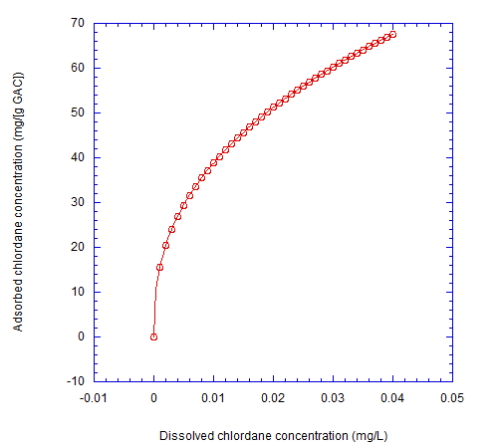

K = 245 $\left(\frac{mg}{g}\right)\left(\frac{L}{mg}\right)$

$\frac{1}{n}=$ 0.4

**Figure 4**. The data plots dissolved chlordane concentration, Caq vs. adsorbed chlordane

concentration, Cadsorbed. The reaction fits a Freundlich sorption isotherm, which

is displayed on the graph above with the K and n values.

No statistical tests for goodness of fit were conducted, but the Freundlich isotherm clearly fits the chlordane data. This isotherm should be used to assess whether treating the water with GAC will reduce chlordane concentrations to below the desired contaminant level of 2 ppb.